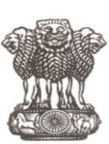
GOVERNMENT OF WEST BENGAL
OFFICE OF THE PRINCIPAL
GOVERNMENT COLLEGE OF EDUCATION, BURDWAN
KAZIRHAT, P.O. - LAKURDI, DIST. - BURDWAN, PIN – 713102
E-MAIL ID – principal.gceburdwan@gmail.com & gceburdwan@yahoo.in
Ph – 03422656853, ESTD.- 1964

Name of the Suspended Employee | Name of the Office/Institution with address | Suspended from | Reason for suspension | Any other details
N.A | Government College Of Education, Burdwan  Address- Kazirhat P.O.- Lakurdi  Purba Bardhaman  713102 | N.A | N.A | N.A

s 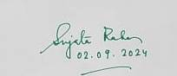s
Dr. Sujata Raha
Officer-in-Charge
Government College of Education, Burdwan
